## **World Cup**

Historical data leading up to the 2022 FIFA World Cup, including all the matches from the previous world cups, all international matches for the qualified countries, and the groups, squads, and matches for the upcoming tournament.

#### **Recommended Analysis**

1. How have host countries performed in World Cups over time? Did Qatar follow a similar path?
2. Based on recent form and historical dominance, which countries underperformed in 2022 tournament? Which countries overachieved?
3. How does Argentina's path to glory compare to previous winners?
4. Has your home country participated in a World Cup? How have they fared?

#### **Want feedback on your solutions?**

* Share visualizations (and any applicable pivot tables, code, etc).

## **Great American Coffee Taste Test**

In 2023, Cometeer partnered with YouTube coffee expert and world champion barista James Hoffmann to host [The Great American Coffee Taste Test](https://cometeer.com/pages/the-great-american-coffee-taste-test). To conduct this first-of-its-kind preference experiment, Cometeer shipped 5,000 coffee kits across America with four different coffees. These were pre-extracted and flash frozen, allowing tasters to melt and dilute the coffee capsules at home for a largely identical tasting experience, all while following along with James during a [YouTube livestream](https://www.youtube.com/watch?v=U489K2t_Tgc&ab_channel=JamesHoffmann) on October 21st, 2023.

The tastings and ratings were conducted blind, but after the survey responses we

#### **Which function, when entered into cell F2 and then dragged to cell F6, returns the performance rating text (e.g., "Good", "Poor") for each representative?**

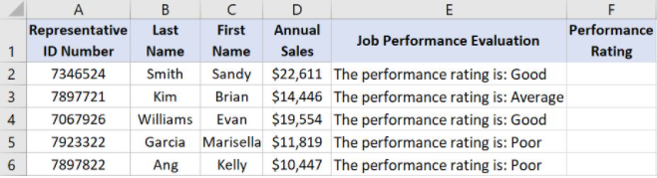

* Correct a.) =RIGHT(E2,LEN(E2)-27)
* =LEN(E2,MID(E2)-27)
* =LEFT(E2,LEN(E2)-27)
* =RIGHT(E2,MID(E2)-27)

#### **Which value is returned when you enter =LEN(C3) into cell F3?**

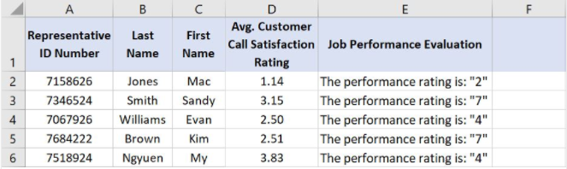

* 4
* ans 5
* 3
* 2

#### **How can you create the lower table from the top one when the tables are not linked?**

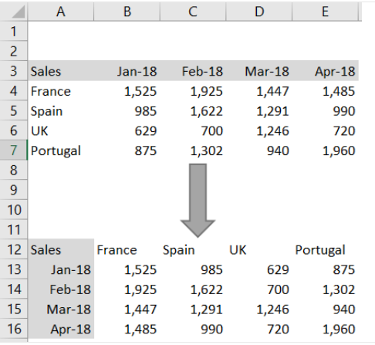

* Select Paste Special > Values.
* ans.Select Paste Special > Transpose.
* Use the TRANSPOSE function
* Click Switch Rows & Columns

#### **Based on the data in columns D,G,H, and K below, what formula will calculate the average compensation for full-time employees who have a job rating of 5?**

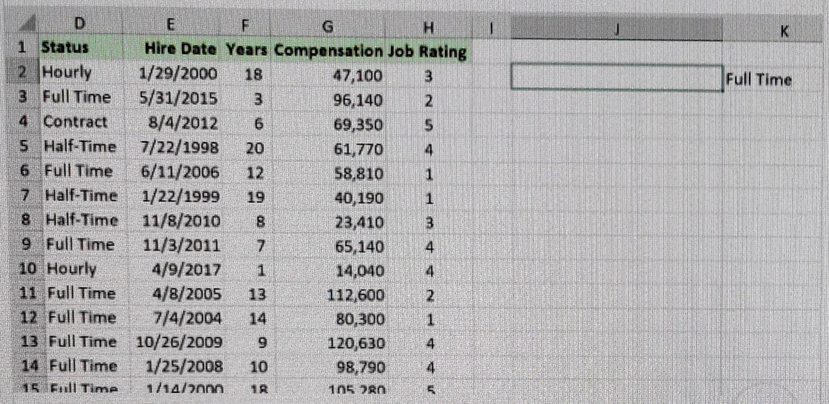

* =AVERAGEIF(D:D,K2,H:H,5,G:G)
* =AVERAGEIF(G:G,D:D,K2,H:H,5)
* =AVERAGEIFS(K2,H:H,5,G:G)
* ans. =AVERAGEIFS(G:G,D:D,K2,H:H,5)

Fertility rate datasets

Questions

1. What is the rate of child per women In india or it is increase or decrease?
2. What is the fertility rate between india and pakistan
3. Which country had the highest fertility rate in 1950?  
   a) Afghanistan  
   b) Africa (UN)  
   c) Algeria  
   d) American Samoa
4. What was the fertility rate of Denmark in 1950?  
   a) 2.5718  
   b) 2.7998  
   c) 2.933  
   d) 3.0638
5. Which country had the lowest fertility rate in 1950?  
   a) Andorra  
   b) Argentina  
   c) Australia  
   d) Austria
6. What was the fertility rate of Egypt in 1950?  
   a) 6.5225  
   b) 6.6052  
   c) 6.6755  
   d) 6.9939
7. Which region had the highest average fertility rate in 1950?  
   a) Africa  
   b) Asia  
   c) Europe  
   d) Oceania

===========================================

1. In 1950 which country was lowest fertility rate(FR)

* Luxembourg (ans)
* Austria
* jersey
* Norway

2.In 2021 which country was lowest fertility rate

* Singapore (ans)
* Italy
* Japan
* Ukraine

3. What is the FR of Hong kong in 2021?

* 5.02
* 6.08
* 7.4 (ans)
* 5.4

4. what difference in FR of india from 1951 to 2021

* 3.741 (ans)
* 2.532
* 3.45
* 2.45

which year the FR of United kingdom and united states was same first time?

* 1965 (Ans)
* 1970
* 1960
* 1968

6. Which age group is most affected due to heart disease?

* 58 (ans)
* 54
* 56
* 57

7. Which age group is the highest affected number in females ?

* Age 62, affected 12 (ans)
* Age 55, affected 20
* Age 60, affected 15
* Age 57, affected 17

8. If chest pain happens then What is the percentage that a patient is affected by heart disease ?

* 52.86% (ans)
* 47.14%
* 55.50%
* 45.55%

9. What is the maximum heart rate of male and females?

* 202, 192 ans
* 200, 190
* 220, 190
* 210,192

10. What is the percentage of people doing exercise angina if they are affected by heart disease?

* 60.89% ans
* 58.50%
* 62.60%
* 60.60%

In 1950, which country had the lowest fertility rate?

1. a) Luxembourg  
   b) Austria  
   c) Jersey  
   d) Norway  
   Answer: a) Luxembourg

In 2021, which country had the lowest fertility rate?

1. a) Singapore  
   b) Italy  
   c) Japan  
   d) Ukraine  
   Answer: a) Singapore

What is the fertility rate of Hong Kong in 2021?

1. a) 5.02  
   b) 6.08  
   c) 7.4  
   d) 5.4  
   Answer: c) 7.4

What is the difference in the fertility rate of India from 1951 to 2021?

1. a) 3.741  
   b) 2.532  
   c) 3.45  
   d) 2.45  
   Answer: a) 3.741

In which year did the fertility rate of the United Kingdom and the United States become the same for the first time?

1. a) 1965  
   b) 1970  
   c) 1960  
   d) 1968  
   Answer: a) 1965

Which age group is most affected by heart disease?

1. a) 58  
   b) 54  
   c) 56  
   d) 57  
   Answer: a) 58

Which age group has the highest number of affected females?

1. a) Age 62, affected 12  
   b) Age 55, affected 20  
   c) Age 60, affected 15